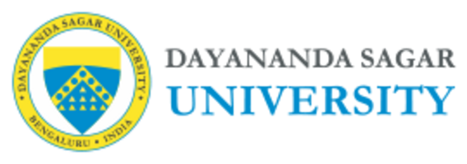

School Of Engineering

Department of Computer Science and Engineering
B Tech, Minor Project - Weekly Progress Report (2025-26)

Semester: VI
^{Week No: 05} From:23/03/2026 To:28/03/2026

Department | CSE-CORE
Names & USN of Team Members | Bhaskar A Gowda | ENG23CS0032
 | Bhavish S Shetty | ENG23CS0035
 | Ranjith Shetty | ENG23CS0424
 | Basavanagouda Meti | ENG23CS0029
Name of the Guide | PROF. YASHPAL GUPTA S
Project Title | PREDICTIVE MODELLING OF TOP INDIAN BANKS’ STOCK PRICE USING NLP, DL AND FINBERT

Work Carried out by the team during the Week (in Bullet points only):
- Applied TimeSeriesSplit cross-validation on the final merged dataset to perform robust temporal validation of the prediction model.
- Trained and evaluated the LSTM model across multiple folds using performance metrics.
- Incorporated additional trend-based evaluation metrics including directional accuracy.
- Analyzed model performance across folds and compared consistency under different splits.
Individual Contribution by Student | Work Carried out
Bhaskar A Gowda | Implemented TimeSeriesSplit cross-validation.
Bhavish S Shetty | Trained the LSTM model across folds and collected metrics.
Ranjith Shetty | Computed trend-based classification metrics, such as accuracy.
Basavanagouda Meti | Analysed cross-validation results and prepared observations.
Work Planned for the Following Week: Optimise the predictive model by tuning hyperparameters and experimenting with improvements to increase forecasting performance.

Major Bottlenecks (If Any):

Percentage Work Completed: 50%

Signature of the Guide: Signature of Students:
- 2.

3. 4.

